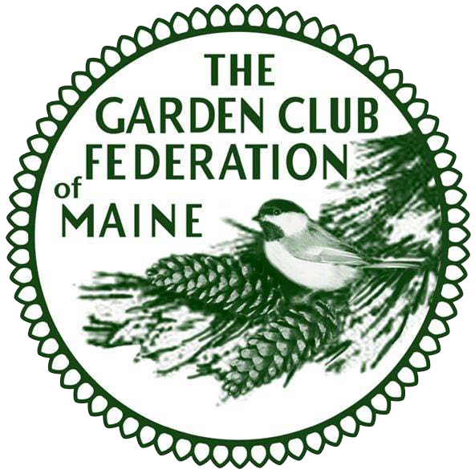
Garden Club Federation of Maine

Application for State Life Membership

The following donations are wonderful gifts to members or for yourself and they also enhance the Scholarship Fund. The Scholarship is awarded to a deserving Maine student majoring in horticulture or related fields at our Annual Meeting. Your contribution is “A Gift that Lasts a Lifetime”.

TYPE OF DONATION: MEMBERSHIP MEMORIAL GIFT GIFT

Name of Applicant for State Life Membership:

Address:
Phone: E-mail:
Garden Club:

Memorial Gift or Gift Given by:

Address:
Garden Club:

State Life Membership: Please send the above information and a check in the amount of
$50.00 payable to GCFM Scholarship Fund:
Memorial Gift: Please send the above information and a check for any amount payable to

GCFM Scholarship Fund.
Scholarship Gift: Please send name and address of Donor or Club and a check payable to GCFM Scholarship Fund for any amount.

Mail to: GCFM Scholarship Chairman Lisa Freeman, 112 Sheepscot Road, Newcastle, ME 04553

All donations will be acknowledged. Form/2023

